**Problem Set 5**

**Research method Problem Set 5 due Wed 5th Dec, 23:59**

**LIU BOWEN (1004028)**

For Problem Set 5, I use the following packages:

|  |
| --- |
| import matplotlib.pyplot as plt  import numpy as np  import scipy as sp  import scipy.stats as ss  from scipy.fftpack import fft, ifft |

**Problem 1**

Answer:

a)

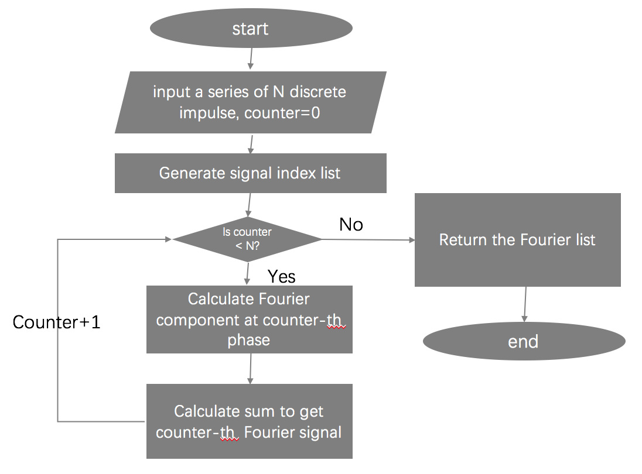

b)

|  |
| --- |
| sample_num=1000  x=np.linspace(0,5,sample_num)  y=5*np.cos((20*np.pi)*x) + 3*np.cos((2*np.pi)*x)  Maxtime=5.  timestep=Maxtime/sample_num  FreqStep =1./( Maxtime )  w=np.fft.fft(y)  plt.figure()  plt.plot(x,y) |

I draw 5 seconds plot and the figure is shown in :

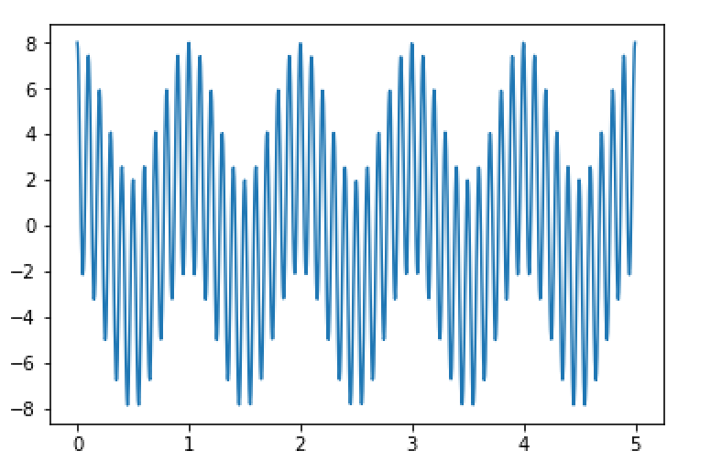

c)

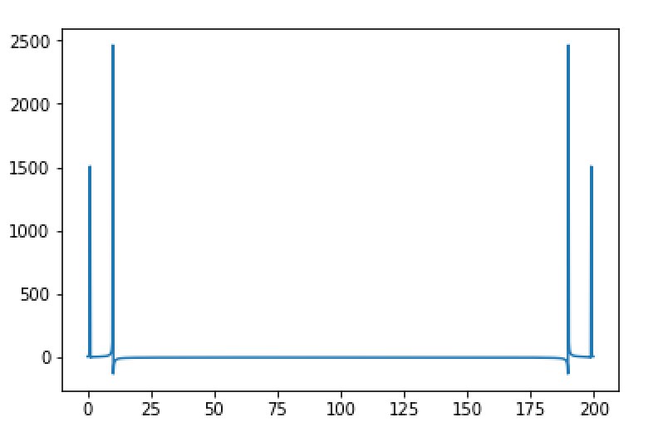

|  |
| --- |
| sample_num=1000  x=np.linspace(0,5,sample_num)  y=5*np.cos((20*np.pi)*x) + 3*np.cos((2*np.pi)*x)  Maxtime=5.  timestep=Maxtime/sample_num  FreqStep =1./( Maxtime )  freq =[]  for i in range(sample_num):  freq.append(i*FreqStep)  def nativeFFT(x):  size = len(x)  samples = np.arange(0, size)  res = []  for i in samples:  res.append(sum(np.exp(-samples * i * 2.0 * np.pi * 1j/size) * y))  return res  ab = (nativeFFT(y))  plt.plot(freq, ab) |

d)

|  |
| --- |
| sample_num=1000  x=np.linspace(0,5,sample_num)  y=5*np.cos((20*np.pi)*x) + 3*np.cos((2*np.pi)*x)  Maxtime=5.  timestep=Maxtime/sample_num  FreqStep =1./( Maxtime )  freq =[]  for i in range(sample_num):  freq.append(i*FreqStep)  w= np.fft.fft(y)  mag=[]  for line in w:  mag.append(np.linalg.norm(line))  plt.figure()  plt.plot(freq , mag)  plt.xlabel('Freq (Hz )')  plt.ylabel('FT Magnitude') |

The result is :

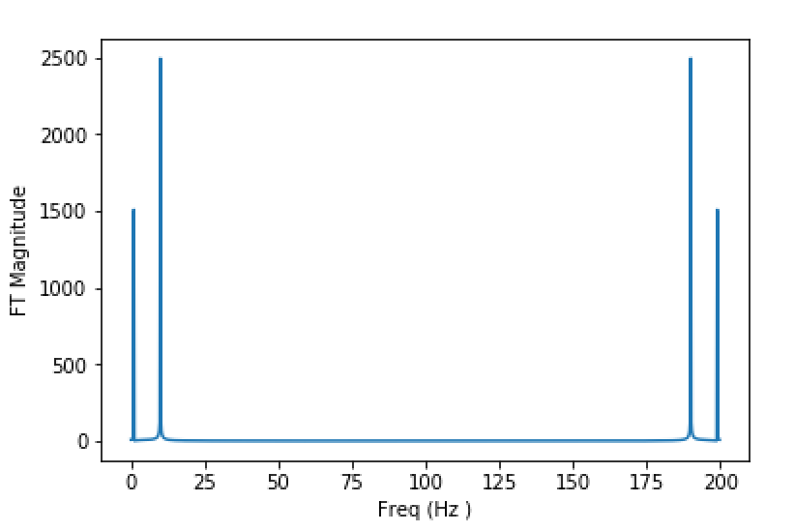

e)

|  |
| --- |
| from scipy.fftpack import fft, ifft  plt.figure()  plt.plot(x, ifft(w)) |

The result is:

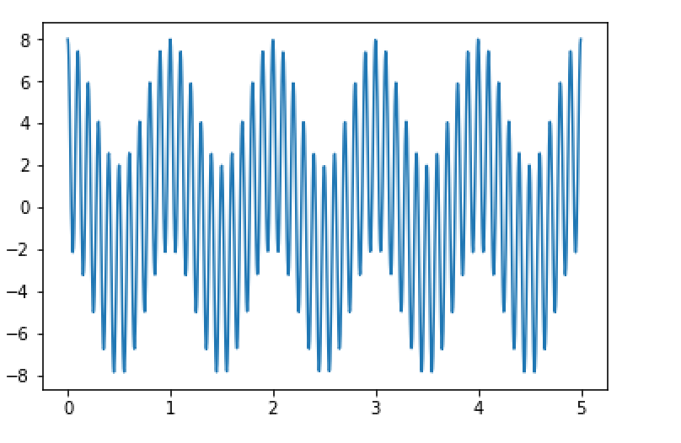

**Problem 2**

Answer:

|  |
| --- |
| def twoFactor():  data = [[[100,140],[180,140]],[[230,210],[160,200]],[[310,270],[210,250]]]  size_data = len(data)  size_data_row = len(data[0])  size_data_unit = len(data[0][0])  DoF1 = size_data-1  DoF2 = size_data_row-1  DoF3 = (size_data-1)*(size_data_row-1)  DoF4 = size_data * size_data_row * (size_data_unit-1)    mean1 = []  for i in range(size_data):  mean1.append(np.mean(data[i]))    mean2 = []  for i in range(size_data_row):  tmp = []  for j in range(size_data):  tmp.append(data[j][i])  mean2.append(np.mean(tmp))    SSA = size_data_row * size_data_unit * np.var(mean1) * len(mean1)  SSB = size_data * size_data_unit * np.var(mean2) * len(mean2)  sse_list = []  for j in range(size_data_row):  for i in range(size_data):  sse_list.append(len(data[i][j])*np.var(data[i][j]))  SSE = sum(sse_list)  SST = np.var(data) * size_data * size_data_row * size_data_unit  SSAB = SST – SSA – SSB - SSE    print 'SSA:',SSA  print 'SSB:',SSB  print 'SSE:',SSE  print 'SST:',SST  print 'SSAB:',SSAB    MSA = SSA/(size_data-1.0)  MSB = SSB/(size_data_row-1.0)  MSAB = SSAB/((size_data-1.0) * (size_data_row-1.0))  MSE = SSE/(size_data * size_data_row * (size_data_unit-1))  print 'MSA:',MSA  print 'MSB:',MSB  print 'MSE:',MSE  print 'MSAB',MSAB  Fa = MSA/MSE  Fb = MSB/MSE  Fab = MSAB/MSE  Fac = ss.f.ppf(0.95, DoF1, DoF4)  Fbc = ss.f.ppf(0.95, DoF2, DoF4)  Fabc = ss.f.ppf(0.95, DoF3, DoF4)  print 'Fa:', Fa  print 'Fb:', Fb  print 'Fab:', Fab  print 'Critical Fa:', Fac  print 'Critical Fb:', Fbc  print 'Critical Fab', Fabc  twoFactor() |

The result is :

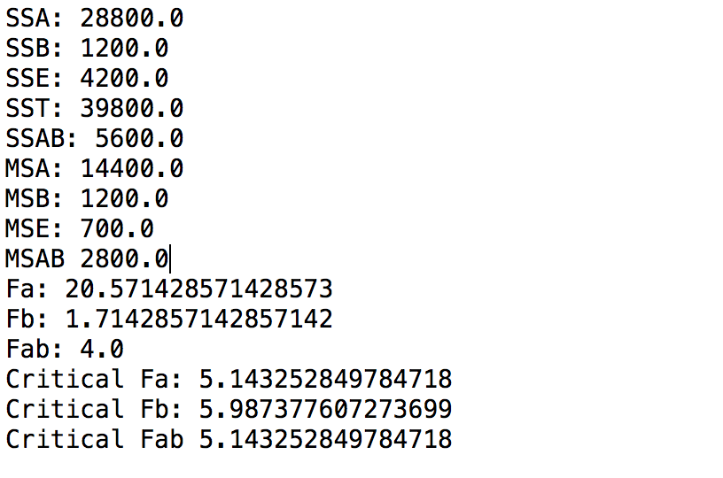

From the results, only Fa > critical Fa so factor A would be significant.

**Problem 3**

Answer:

The max frequency is 100 and the question need to plot 0.4s so the twice minimum sample point is 100*0.4*2*2 = 160

a)

|  |
| --- |
| Ns= 160 #number of samples  time = np.linspace(0, 0.4, Ns, endpoint = False)  y=20 + 10*np.cos((2*np.pi)*50*time) + 5*np.cos((2*np.pi)*10*time) + 20*np.cos((2*np.pi)*100*time)  Maxtime = 0.4  timestep = Maxtime/Ns  FreqStep =1./( Maxtime )  freq =[]  for i in range(Ns):  freq.append (i*FreqStep)  w = np.fft.fft(y)  plt.figure()  plt.plot(freq ,w)  plt.xlim (0, 400) |

The result is below and there are 7 Fourier components (including 4 components presented at lower Hz and other higher 3 components are symmetry components).

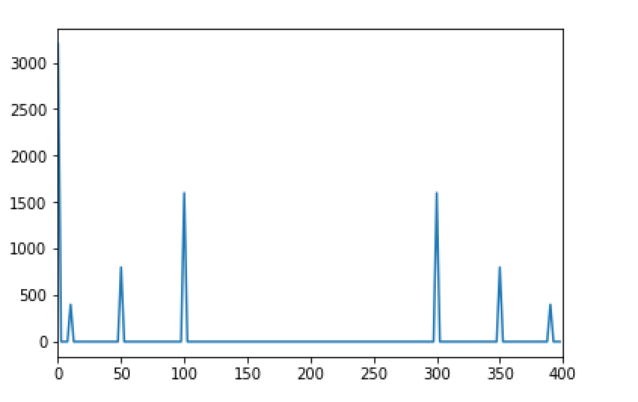

b)

|  |
| --- |
| def window(freq, spec, f):  F_spec=spec  F_spec[f]=0  return F_spec  filtered0 = window(freq, w, 0)  plt.figure()  plt.plot(freq, filtered0)  plt.xlim (0 ,400)  plt.figure()  plt.plot(time,y, 'r')  F_spec= np.fft.ifft(filtered0)  plt.plot(time, F_spec, 'g') |

window() function can remove the 0 hz from the frequency spectrum. Then, I use ifft to replot against f() and the red one is before and green one is after.

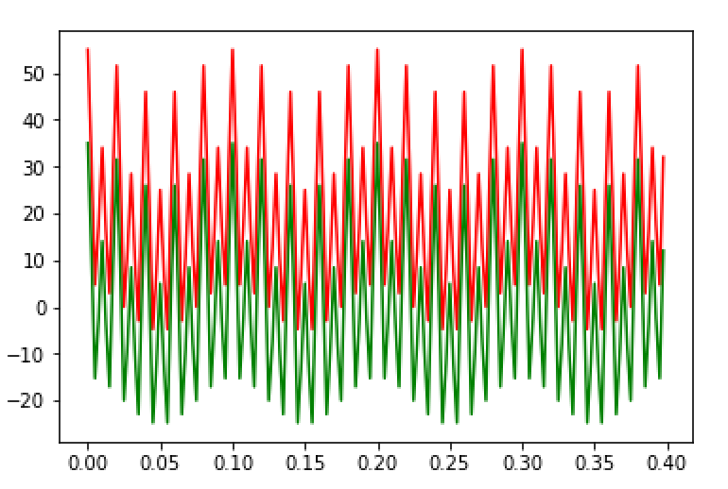

c)

|  |
| --- |
| Ns= 160 #number of samples  time = np.linspace(0, 0.4, 160, endpoint = False)  y=20 + 10*np.cos((2*np.pi)*50*time) + 5*np.cos((2*np.pi)*10*time) + 20*np.cos((2*np.pi)*100*time)  FreqStep = 1./0.4  freq = np.arange(0,len(time)*FreqStep,FreqStep)  f = [sum(np.exp(-time*i*2*np.pi*1j)*y) for i in freq]  y_removeTime = np.fft.ifft(f * (freq==0))  plt.figure()  plt.plot(time, y_removeTime)  plt.plot(time, y) |

The result is shown below, the orange one is for previous f(t) and the blue straight line is for removing time varying signal.

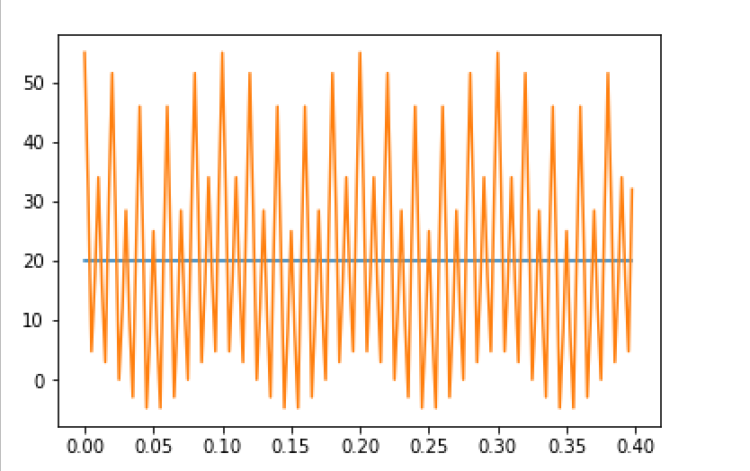

d)

|  |
| --- |
| def window(freq, spec, f0):  indx0 = freq.index(f0)  F_spec=spec  F_spec[indx0]=0  indx0 = freq.index(f0)  indx02 = len(freq) - indx0  F_spec[indx02] = 0  return F_spec  filtered50 = window (freq, w, 50)  plt.figure()  plt.plot(time, y, 'b')  F_spec=np.fft.ifft(filtered50)  plt.plot(time, F_spec, 'r') |

The result is shown below, the blue one is for previous figure and the read one is after removing 50 Hz, and if I need to remove 50 Hz and 350 Hz also needs to be removed.

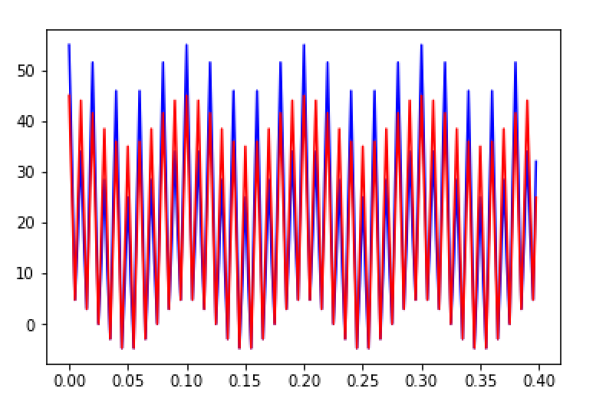

e) If removing the below 100 Hz, the range above 300 Hz also needs to be removed.

|  |
| --- |
| def window(freq, spec, f0):  indx0 = freq.index(f0)  indx02 = len(freq) - indx0  F_spec=spec  F_spec[0: int( indx0 )]=0  F_spec[indx02+1: len(freq)]=0  return F_spec  filtered50 = window (freq, w, 100)  plt.figure()  plt.plot(time,y)  F_spec=np.fft.ifft(filtered50)  plt.plot(time, (F_spec)) |

The result is below and the blue one is before and orange one is after.

